**Liquid Neural Networks: Revolutionizing AI with Dynamic Information Flow**

[[Bhaumik Tyagi](https://tyagi-bhaumik.medium.com/?source=post_page-----30e27f1cc912--------------------------------)](https://tyagi-bhaumik.medium.com/?source=post_page-----30e27f1cc912--------------------------------)

[Bhaumik Tyagi](https://tyagi-bhaumik.medium.com/?source=post_page-----30e27f1cc912--------------------------------)

·

[Follow](https://medium.com/m/signin?actionUrl=https%3A%2F%2Fmedium.com%2F_%2Fsubscribe%2Fuser%2Fc2a8de071e5c&operation=register&redirect=https%3A%2F%2Ftyagi-bhaumik.medium.com%2Fliquid-neural-networks-revolutionizing-ai-with-dynamic-information-flow-30e27f1cc912&user=Bhaumik+Tyagi&userId=c2a8de071e5c&source=post_page-c2a8de071e5c----30e27f1cc912---------------------post_header-----------)

3 min read

·

Jul 14

278

5

Inthe realm of artificial intelligence, neural networks have proven to be incredibly powerful tools for solving complex problems. Over the years, researchers have continuously sought innovative approaches to enhance their performance and expand their capabilities. One such approach is the concept of Liquid Neural Networks (LNNs), a fascinating framework that harnesses the power of dynamic computation. In this article, we will delve into the world of LNNs, exploring their underlying principles, discussing their advantages, and providing a code implementation accompanied by insightful visuals.

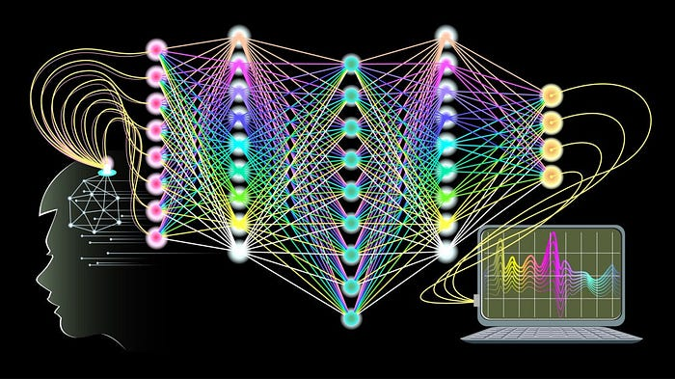

(Image by google)

**Understanding Liquid Neural Networks:**

Liquid Neural Networks (LNNs) draw inspiration from the behavior of liquids and aim to replicate their dynamic nature in the computational domain. In traditional neural networks, computations are performed through fixed weights and connections between neurons. Conversely, LNNs introduce dynamic connectivity patterns, allowing information to flow and interact in a fluid manner.

**Key Advantages of LNNs:**

1. Adaptability: LNNs exhibit remarkable adaptability to changing input patterns. Their dynamic nature enables them to respond dynamically to varying data distributions, making them well-suited for tasks involving non-stationary data.
2. Robustness: LNNs have shown improved robustness against noise and input variations. The fluid-like behavior allows them to self-adjust and filter out irrelevant information, leading to enhanced generalization capabilities.
3. Exploration of Solution Space: LNNs encourage solution space exploration by providing flexibility in the network’s structure. The dynamic connectivity patterns enable the network to explore diverse pathways, potentially discovering novel solutions to complex problems.

*Code Implementation:*

To better understand the functioning of LNNs, let’s explore a simple code implementation using Python and the PyTorch library. In this example, we will build a Liquid Neural Network using an Echo State Network (ESN) architecture, a popular variant of LNNs.

import torch  
import torch.nn as nn  
  
class ESN(nn.Module):  
 def __init__(self, input_size, reservoir_size, output_size):  
 super(ESN, self).__init__()  
 self.reservoir_size = reservoir_size  
 self.W_in = nn.Linear(input_size, reservoir_size)  
 self.W_res = nn.Linear(reservoir_size, reservoir_size)  
 self.W_out = nn.Linear(reservoir_size, output_size)  
  
 def forward(self, input):  
 reservoir = torch.zeros((input.size(0), self.reservoir_size))  
 for i in range(input.size(1)):  
 input_t = input[:, i, :]  
 reservoir = torch.tanh(self.W_in(input_t) + self.W_res(reservoir))  
 output = self.W_out(reservoir)  
 return output  
  
# Example usage  
input_size = 10  
reservoir_size = 100  
output_size = 1  
  
model = ESN(input_size, reservoir_size, output_size)

In the provided code snippet, we define a simple ESN class inheriting from nn.Module in PyTorch. The ESN consists of three linear layers: W_in, W_res, and W_out. W_in represents the input weight matrix, W_res represents the reservoir weight matrix, and W_out represents the output weight matrix.

The forward method processes the input data sequentially, updating the state of the reservoir at each time step. Finally, the output is obtained by applying the W_out transformation to the final reservoir state.

**Visualizing the Dynamics:**

Here are two common visualizations used to illustrate the behavior of LNNs:

1. Reservoir State Visualization: By plotting the reservoir state over time, we can observe how the network’s dynamics evolve in response to the input. This visualization provides insights into the network’s transient behavior and its ability to retain information over time.
2. Connectivity Matrix Visualization: The connectivity matrix, also known as the weight matrix, depicts the network’s strength and pattern of connections. Visualizing this matrix allows us to understand how information propagates and interacts within the network.

Conclusion: Liquid Neural Networks (LNNs) offer a dynamic and adaptable alternative to traditional neural networks. By embracing the concept of liquid dynamics, LNNs excel in tasks involving non-stationary data, exhibit robustness against noise, and enable the exploration of diverse solution spaces. With the provided code implementation and visualizations, researchers and practitioners can further explore LNNs and leverage their capabilities in solving complex real-world problems.

To conclude, LNNs represent just one avenue of exploration in the vast field of artificial intelligence. As researchers continue to push boundaries and uncover new insights, we eagerly anticipate the future advancements that will revolutionize the world of machine learning and AI.

Thank you & follow for more.